SBT GUI Training Outline

- GUI Swing Framework / Architecture
  - CBOE* components (CBOEJButton, CBOEJCheckBox, CBOEJCheckBoxMenuItem, CBOEJRootPane, CBOEJDialog, CBOEJFormattedTextField, CBOEJLabel, CBOEJList, CBOEJMenu, CBOEJMenuBar, CBOEJMenuItem, CBOEJPanel, CBOEJPasswordField, CBOEJPopupMenu, CBOEJProgressBar, CBOEJRadioButton, CBOEJRadioButtonMenuItem, CBOEJComboBox, CBOEJScrollPane, CBOEJSpinner, CBOEJSplitPane, CBOEJTabbedPane, CBOEJTable, CBOEJTextArea, CBOEJTextField, CBOEJToggleButton, CBOEJToolBar, CBOEJToolTip, CBOEJTree, SBTFrame, TopFrame, ConfigurableTopFrame, SBTDialog)
    - Common: GlassPane, Preferences, SBTStatusBar Helper, L&F, SharedLockReference for Threading, Permissions, ?
    - CBOEJDialog & SBTDialog: SBTStatusBar.

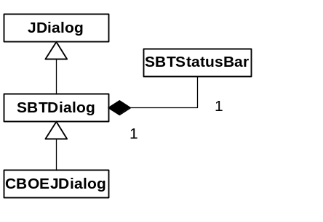

    - SBTFrame, TopFrame, ConfigurableTopFrame: SBTStatusBar, Integration with Window Management, Integration with Preferences.

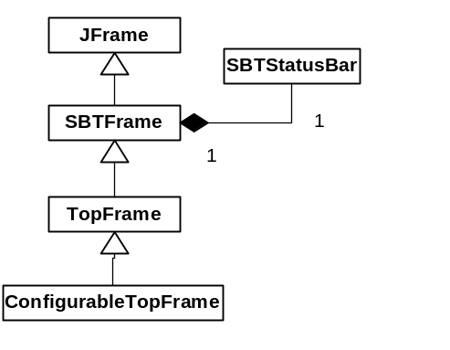

    - CBOEJTable: Built in sorting, filtering, extensive preferences, different methodology for integrating comparators, renderers, rows, column definitions, ?
    - CBOEJComboBox: type ahead searching.
    - Other individual convenience methods and additions.
  - Window Management
    - Main Window
      - Toolbar Pages
    - TopFrameRegistry
      - Main Window Open Tasks Toolbar Page
    - LaunchActionRegistry
      - Preferences, GUI Properties, Start Menu
      - LaunchAction, NamedConfigLaunchAction, LaunchActionType
      - Entries need made to the *GUI.properties to include new menu items on the StartMenu.
  - Custom models for table, combo box, list, spinner, etc.
    - Provides sorting, filtering, coordination of other additional features, ?
  - Preferences
    - Business
    - GUI
      - setName(String) on all components
      - Preferences are obtained from the containment hierarchy of the Frame.
      - setPreferences and getPreferences can be overridden for custom functionality.
    - Can be saved locally or globally to server. (Slightly different for InstrumentationMonitor)
    - Conversion (separate document available)
      - GUI preferences can be broken by a containment hierarchy change.
      - Before and after image must be compared to determine impact.
  - Threading
    - SwingEventThreadWorker
      - Ability to schedule processing on the Swing thread, from a non-Swing thread.
      - InvokeAndWait – can be contentious with GUIWorker & APIWorker if any locking is performed.
      - invokeLater – cannot expect return type or exceptions.

final Object dataToWorkWith;
SwingEventThreadWorker worker = new SwingEventThreadWorker(true)
{
public Object process()
{
//do something with dataToWorkWith
//that requires Swing thread
return null;
//or return someResult;
}
};
try
{
worker.doProcess();
//or Boolean result = (Boolean)worker.doProcess();
}
catch(Exception e)
{
DefaultExceptionHandlerHome.find().process(e);
}

    - GUIWorker & APIWorker
      - initializeView
      - execute
      - processData
      - cleanupView
      - handleException
      - sharedLockReference

GUIWorkerImpl worker = new GUIWorkerImpl()
{
public void initializeView()
{
//on Swing Thread
setGlassPaneEnable(true);
}

public void execute() throws Exception
{
//non-Swing Thread
//do some processing, maybe calling API
}

public void processData()
{
//on Swing Thread
//represent some returned data to GUI
}

public void cleanUpView()
{
//on Swing Thread
setGlassPaneEnable(false);
}

public void handleException(Exception e)
{
//on Swing Thread
DefaultExceptionHandlerHome.find().process(e);
cleanUpView();
}
};

APIWorkerImpl.run(worker);

    - IEC – Internal Event Channel
      - Subscribing / unsubscribing
        - Always subscribing to Translator – puts your passed EventChannelListener on IEC with specific ChannelKey
      - EventChannelListener – channelUpdate(ChannelEvent)
      - ChannelKey

ChannelKey channelKey = (ChannelKey) event.getChannel();
if(channelKey.channelType == ChannelType.IC_ALARM_NOTIFICATION)
{
AlarmNotification[] notifications = (AlarmNotification[]) event.getEventData();
//do something with notifications
}

      - IDL consumers
  - Logging
    - GUILoggerHome.find().* (alarm, audit, nonRepudiationAudit, debug, exception, information)
    - Information, Debug
      - check to see if enabled
      - use appropriate business property to define category
        - also check to see if business property enabled
  - ExceptionHandling
    - DefaultExceptionHandlerHome.find().process(e, "");
    - org.omg.CORBA.UserException is superclass to all CORBA defined exceptions
  - Home Pattern
    - Home class to obtain interface from for operations.
    - At runtime, Home is passed the implementation of that interface to provide the services.
    - Allows common code to be written generically against the Home and interface, which at runtime communicates to a specific CORBA application layer, indirectly. Provides binding of common code to specific CORBA application layer at runtime, without compromising the reuse of the common code.

- Business Application Layers
  - ICS, CAS, SACAS
  - Translator
    - Business logic
    - Conversion of IDL structs to objects with business behaviors
    - Caching
    - Provides common interfaces for all GUI’s with different implementations depending upon the CORBA application layer we are communicating with.

- CC JAR Dependency Layout
  - (See attached)

- CC / Build Process
  - clearmake –C gnu all install
    - /vobs/dte/sbtcommon/build/Makefile
    - /vobs/dte/gui/Java/Makefile
      - client interfaces; client common; client commonTranslator; client translator; sysAdminClient interfaces; client intermarketTranslator; client internalTranslator; client instrumentationTranslator; client messagingTranslator; client fixTranslator; gui common; gui commonBusiness; gui trader; gui stock; gui fixTrader; gui admin; gui clientTest; gui instrumentationMonitor; gui messageMonitor
  - The library cross dependencies are enforced through the Makefile’s and they are considered the rule. IDE builds are not considered valid for check in.

- GUI Release directory structure
  - bin – files for direct execution
    - setEnvironment.bat – sets classpath and path; path is changed to include specific VM version compatible for specific GUI.
    - startGui.bat – usually contains some specific variables that need configured for the specific environment
  - classes – contains all necessary JAR’s for specific GUI. CC soft-links to JAR location within appropriate VOB’s.
  - etc – contains specific settings files
    - LoggingService.properties – Defines the local LoggingService from infrastructure.
    - *Gui.properties – contains program operation settings for specific GUI.
    - *Server.properties or FF.properties – usually contains some specific settings that need configured for the specific environment
  - lib – contains platform specific native libraries needed for specific GUI
  - log – default logging output directory

